**Sales Dashboard**

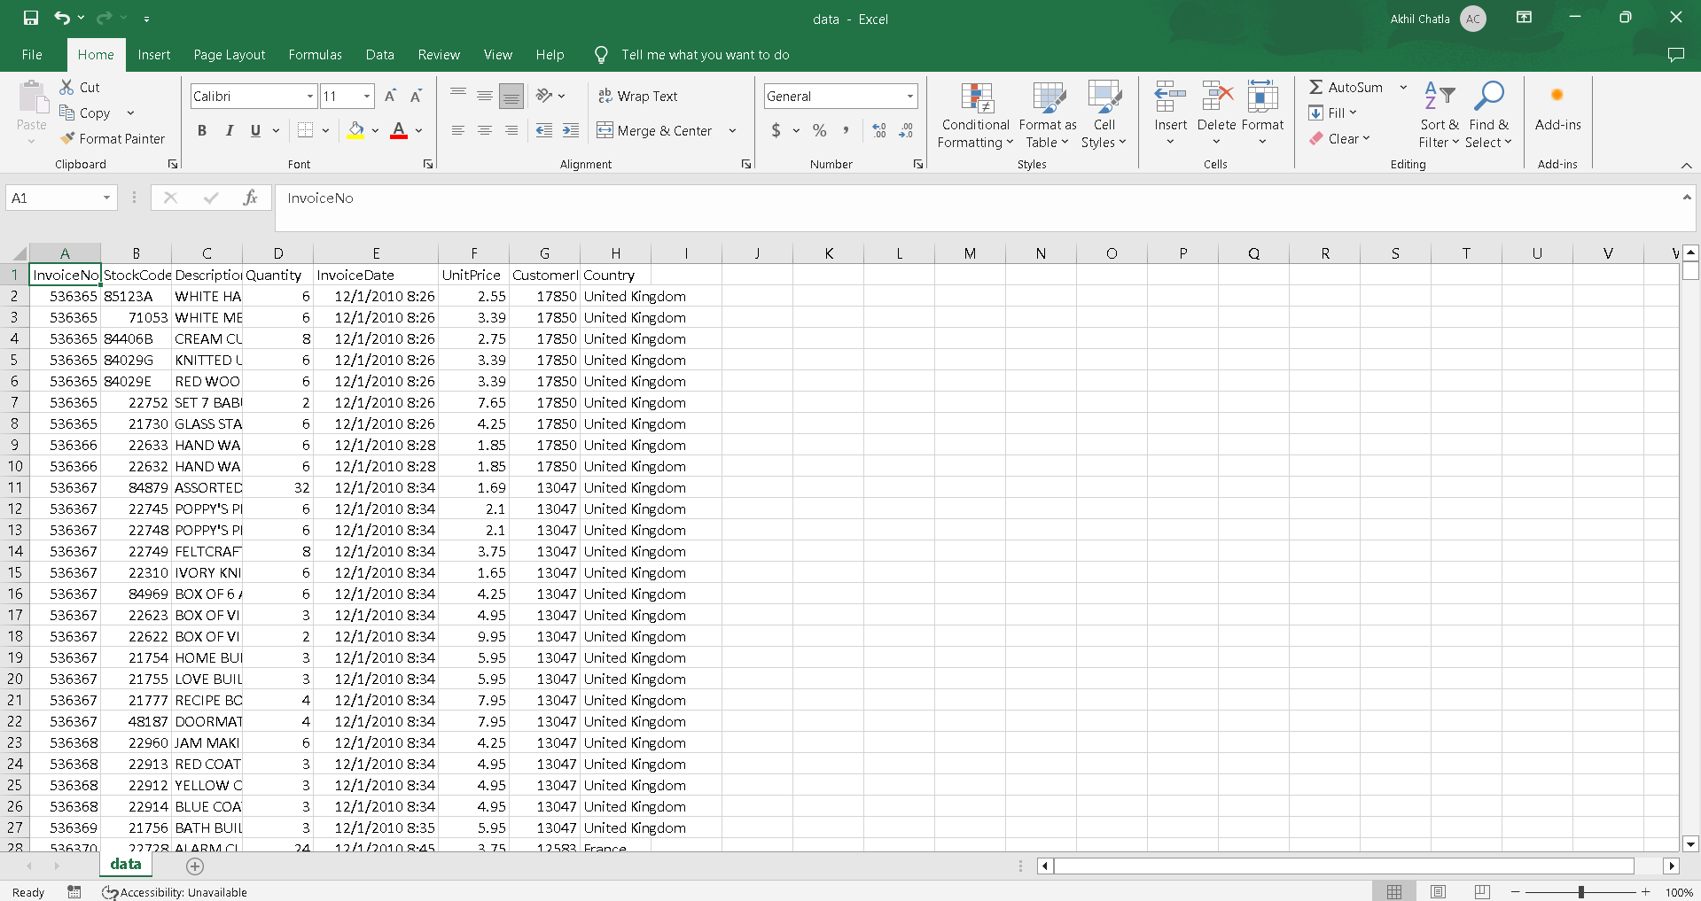

**Cleaning Dataset**

Adding filters to first row

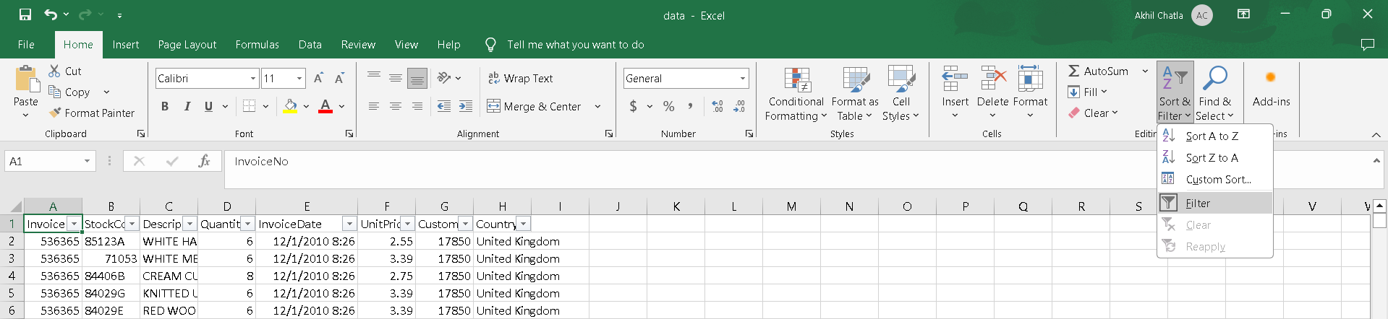

Deleting blank rows  
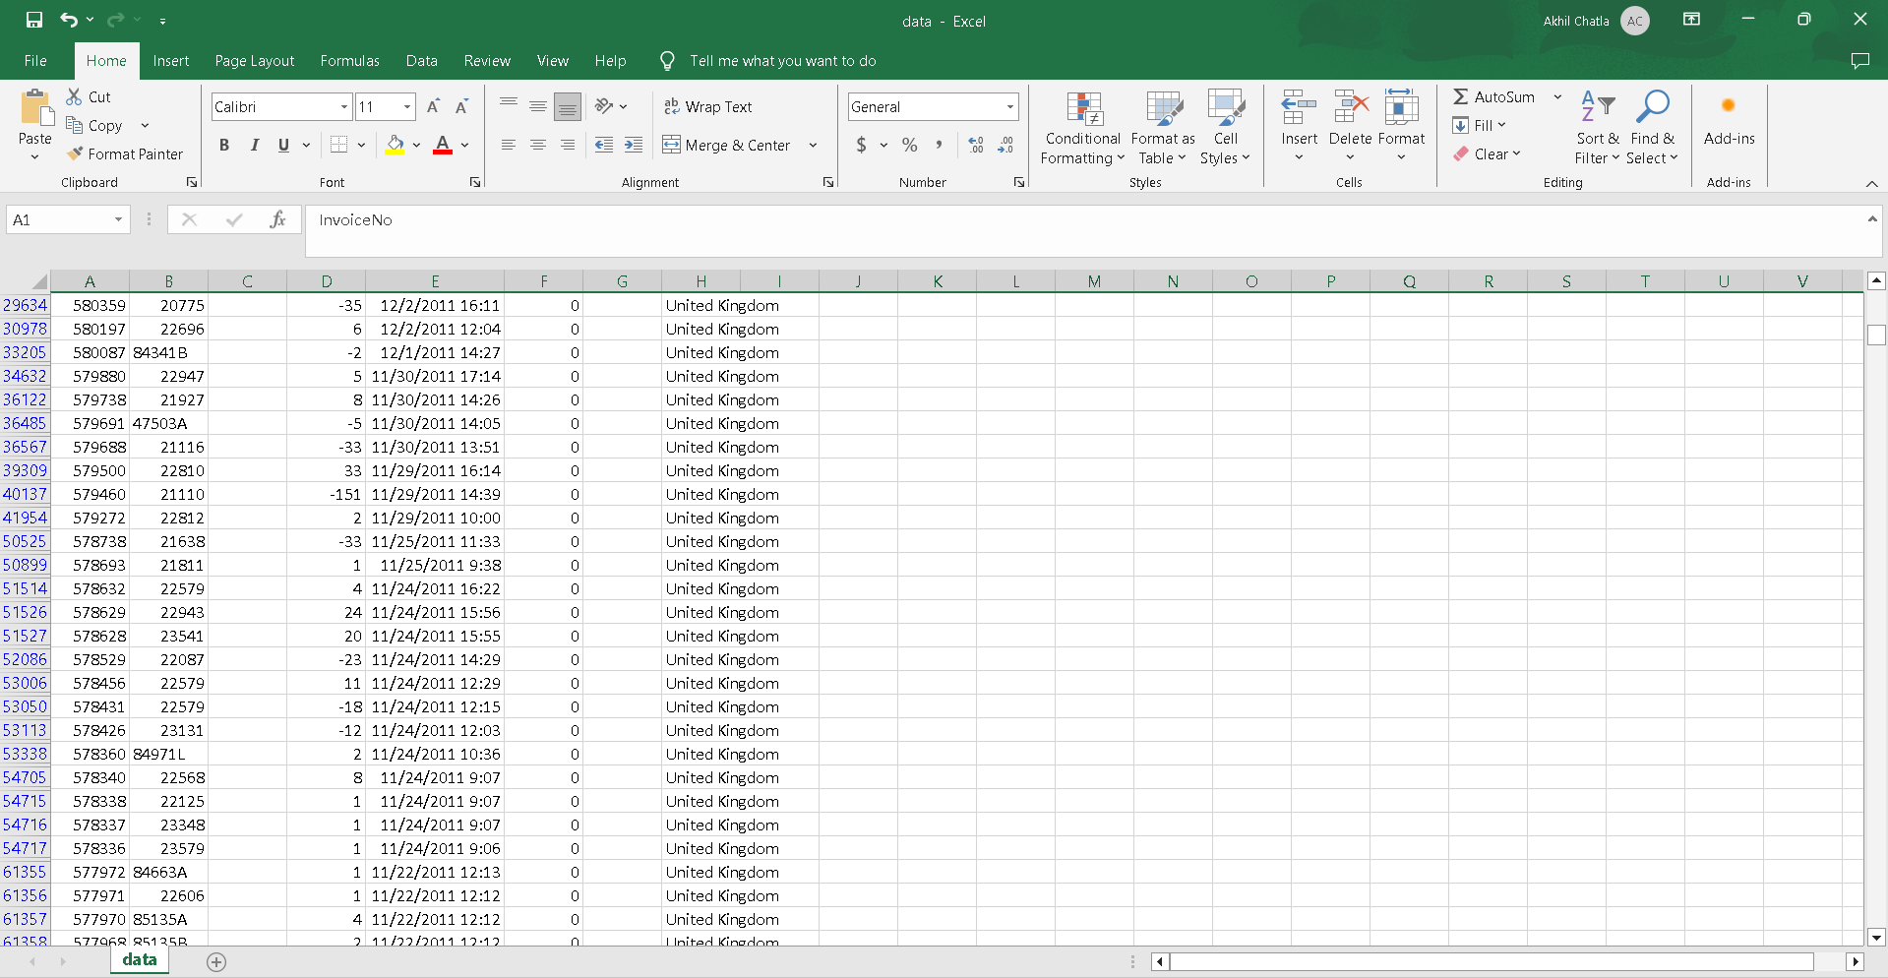

Power Query Cleaning

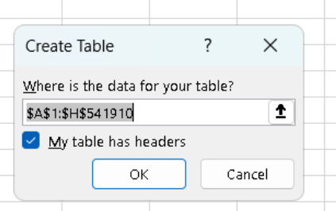

Power query editor opens

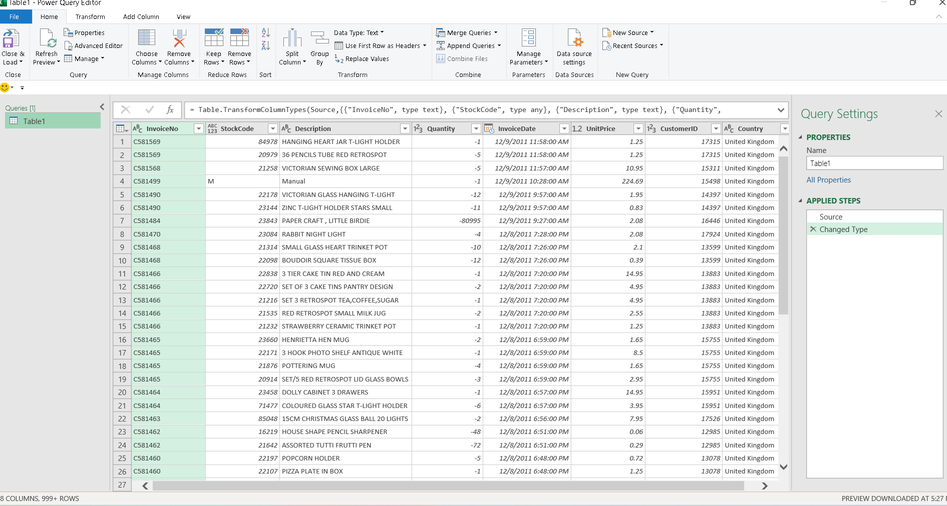

Removing blank rows

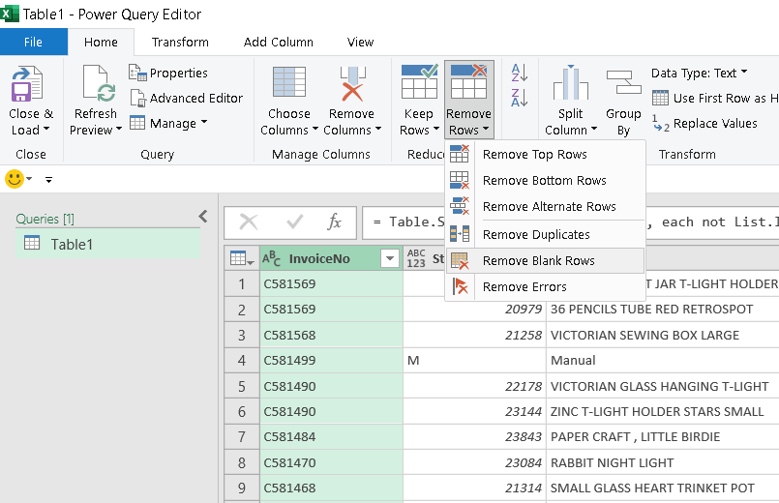

Null rows unchecked

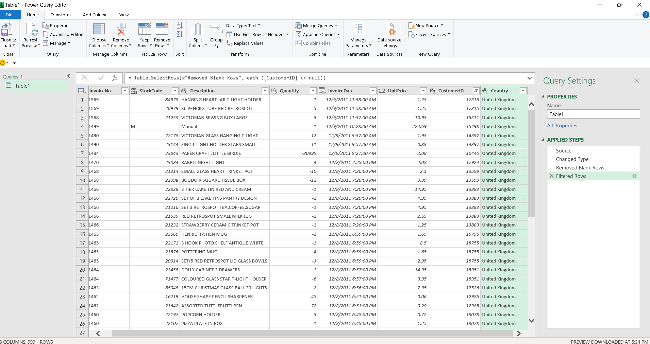

Add a Custom Column: TotalAmount

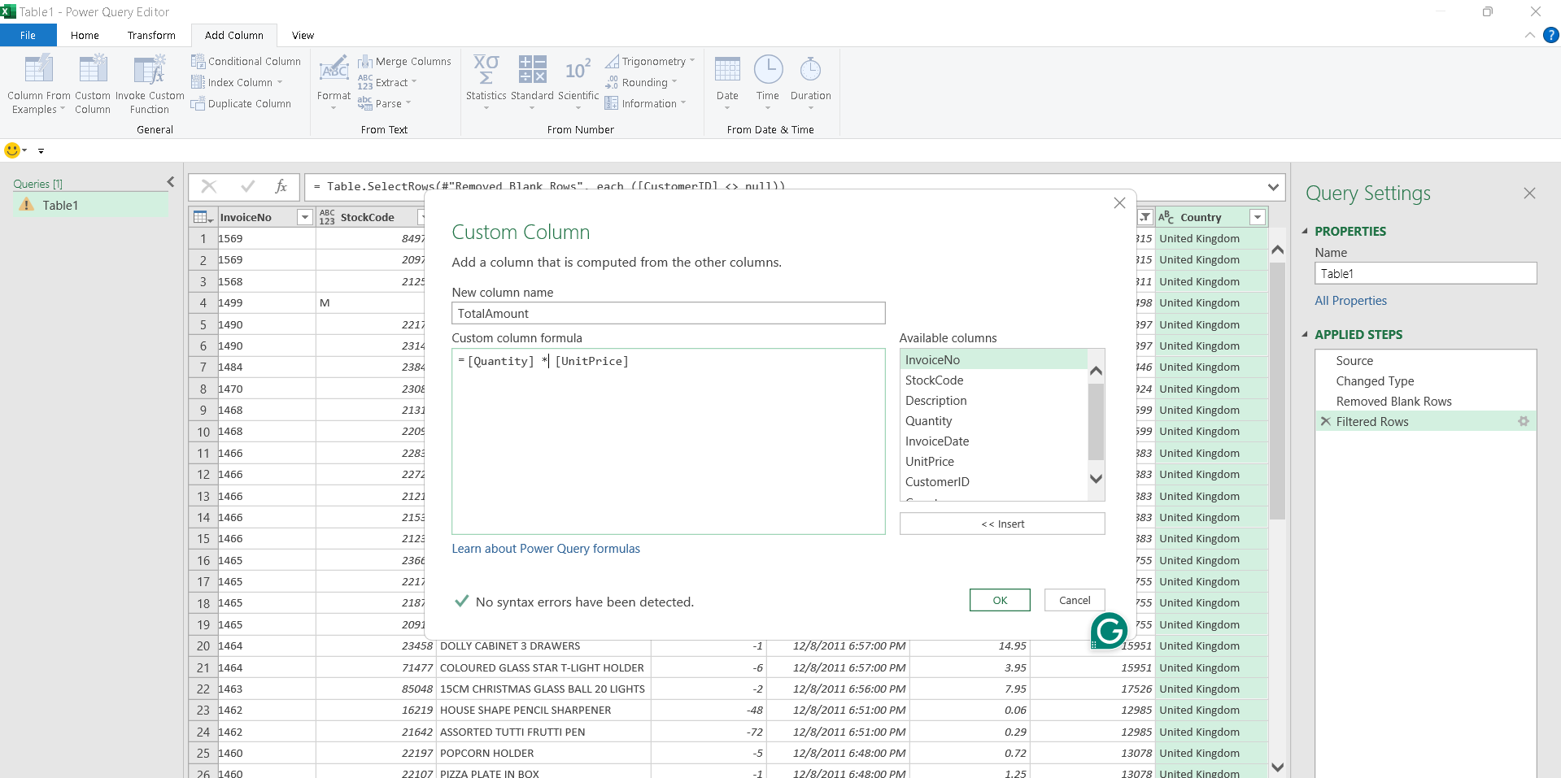

**Add Column: Month**

Click the InvoiceDate column

Add Column tab → Date → Month → Name of Month

Add Column → Date → Year → YearAdd Column → Format → Merge Columns

Choose separator: **space**, Columns: **Month** and **Year**,New column name: MonthYear

Home → Close & Load → Close & Load To…

Table → New Worksheet

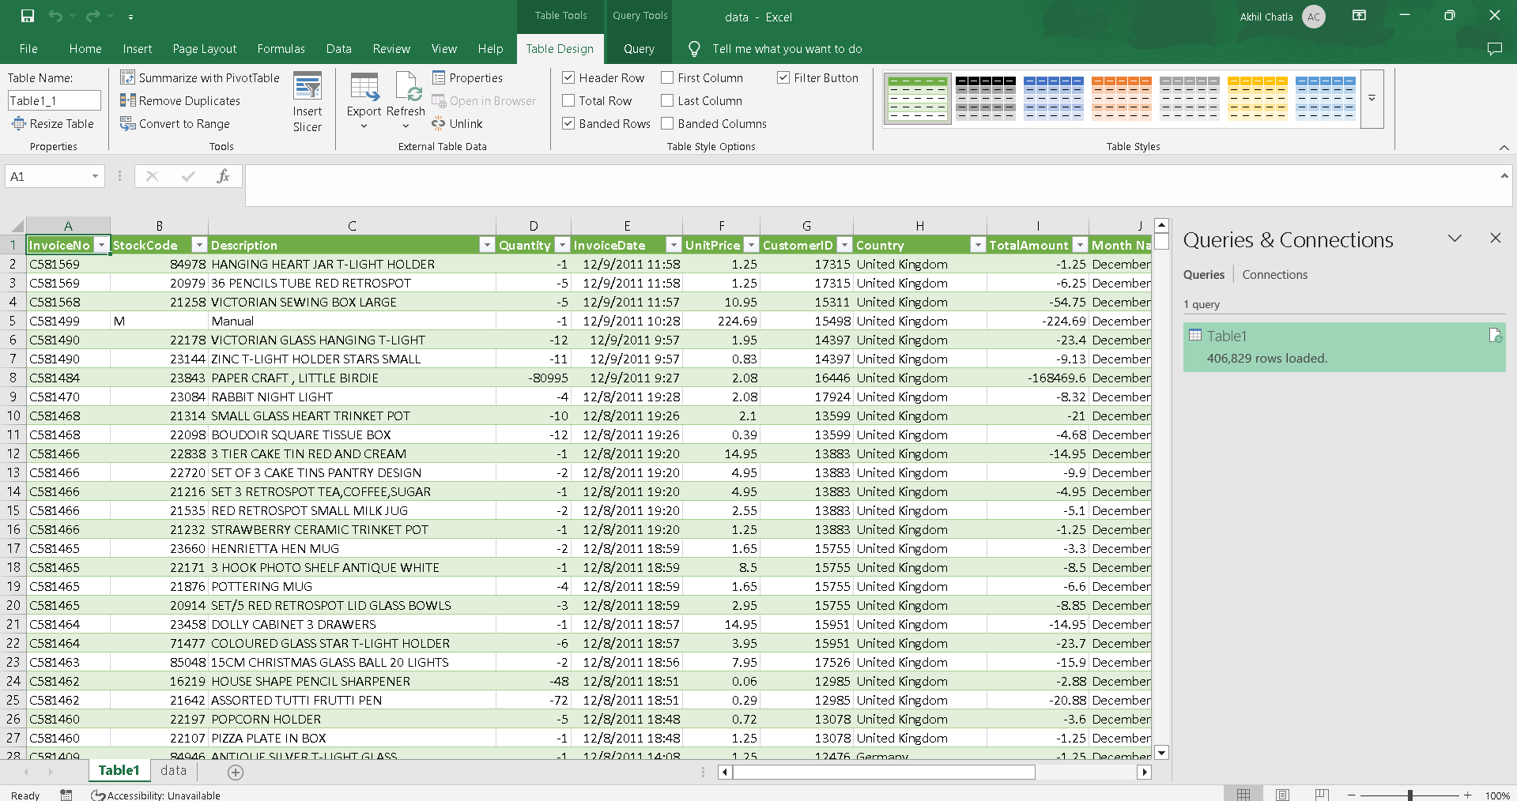

From Table/range

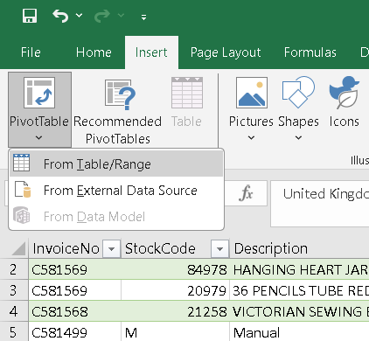

Choose new worksheet, click ok

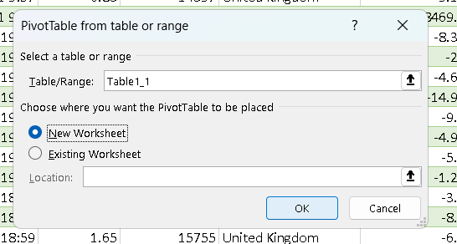

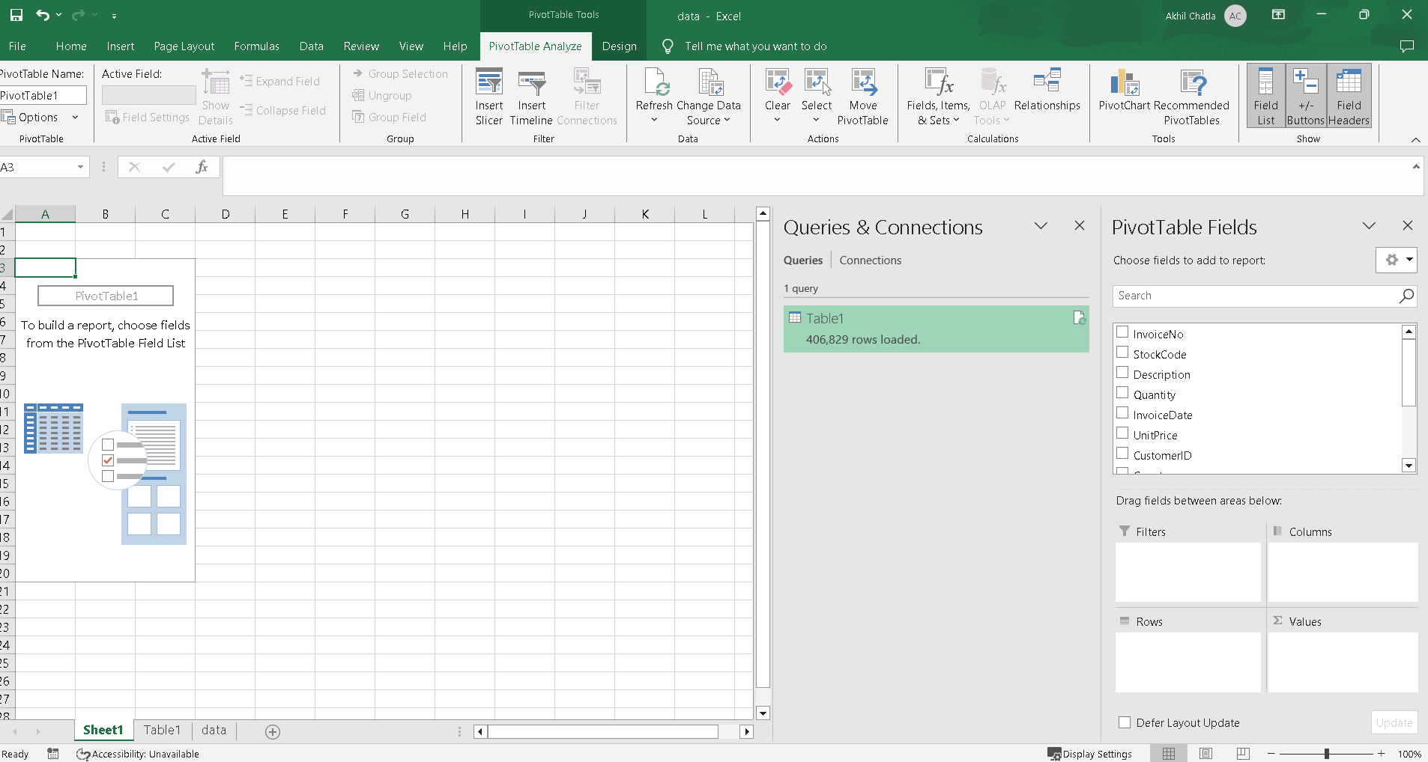

Drag Country to rows, TotalAmount to values,

We get total revenue per country!

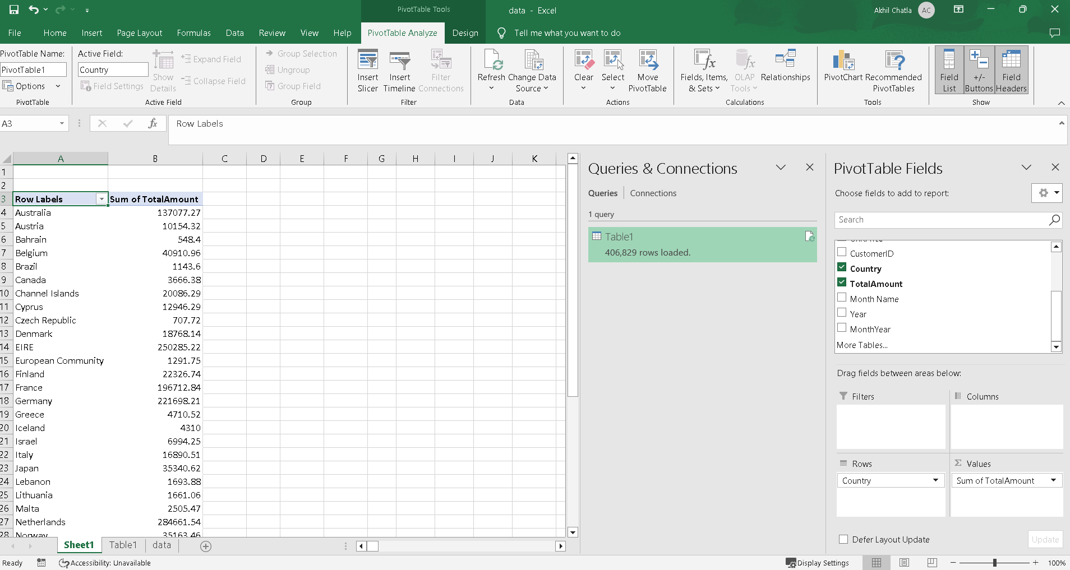

Clustered column Chart

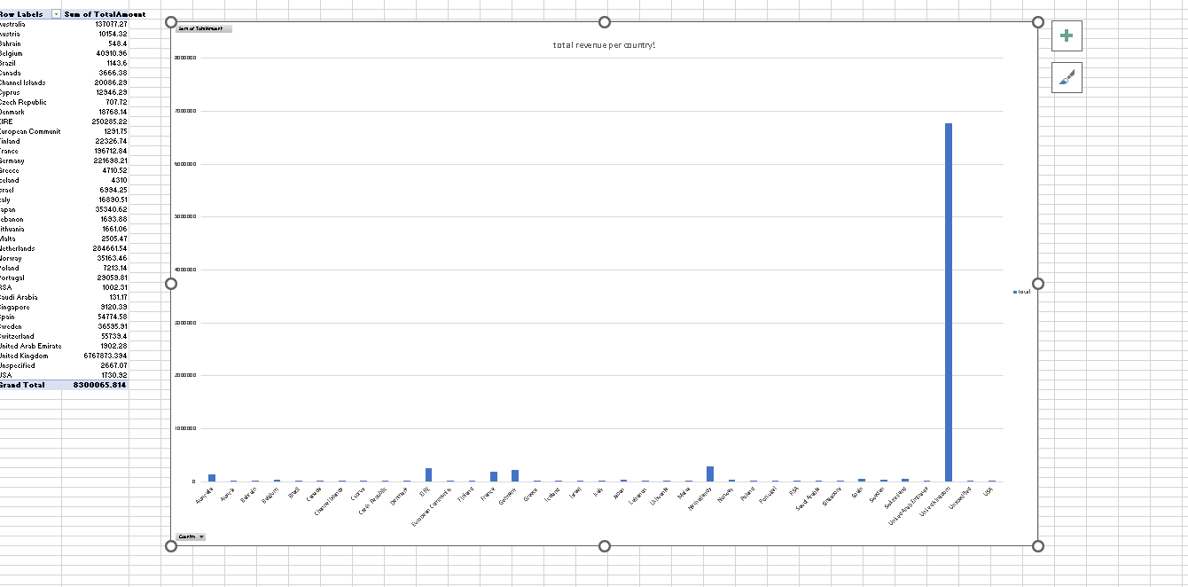

Line Chart of Monthly sales trend

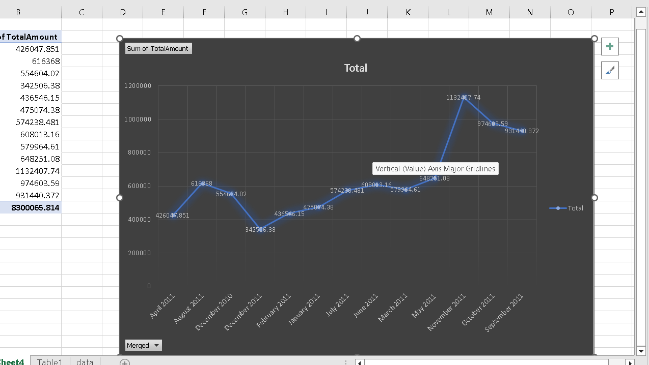

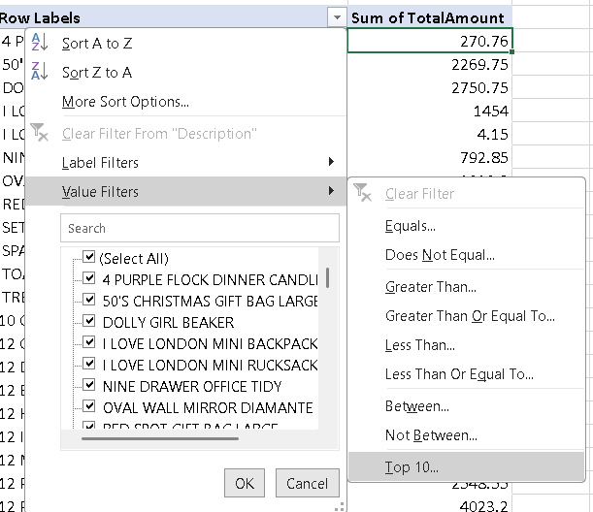

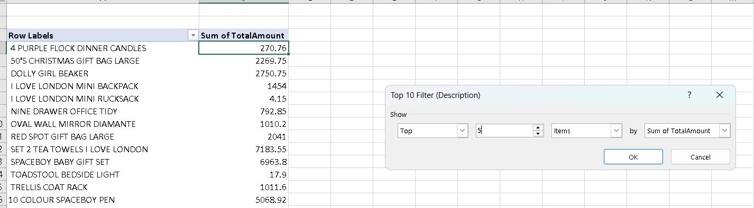

These are the top 5 counties by revenue

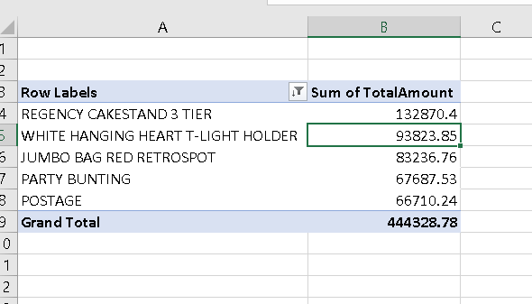

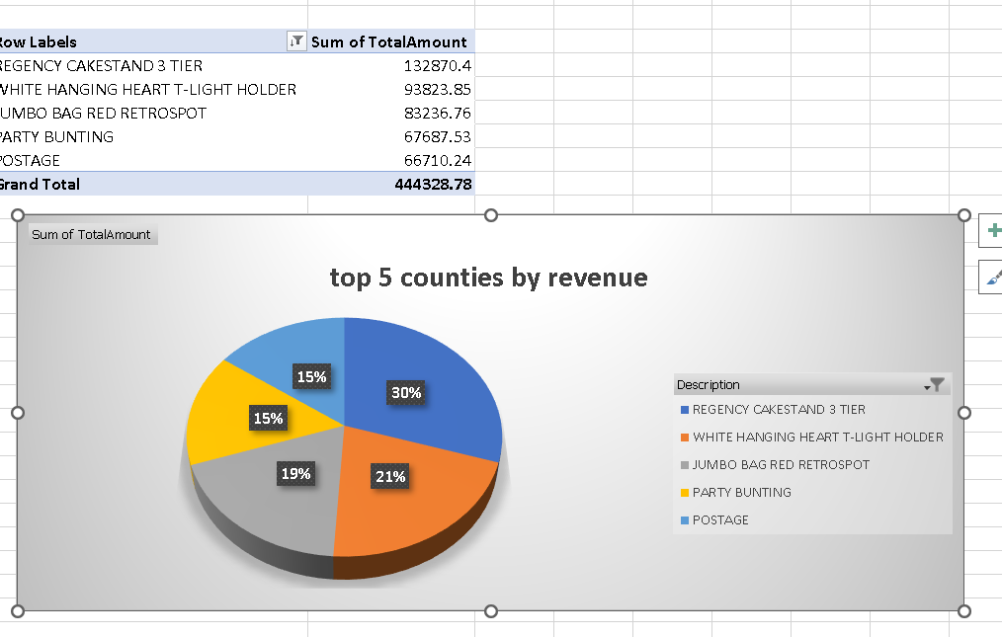

Monthly sales trend

